Day- 1 AWS
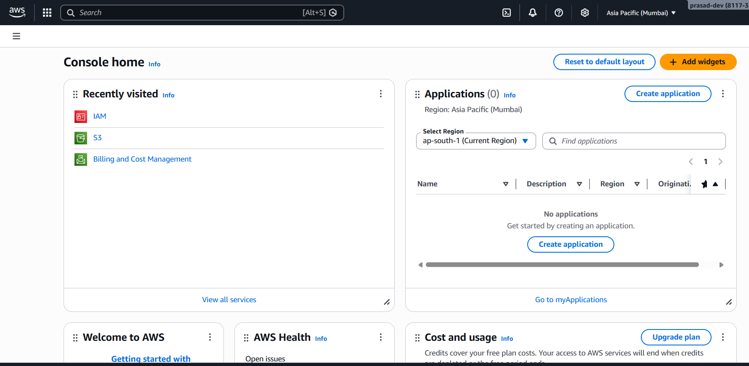
This the AWS Console home.
User Accounts
There are two type of user accounts in AWS where we can login.
- Root User(Administrator have full permissions)
- Can login email and password
- IAM User(Provided by administrator and have limited permissions
- Can login using username and password
Root account is called the parent account who can create any number of IAM acocunts.

IAM – Identity Access Management
- The main account is called Root Account.
- We can control entire AWS using IAM providing proper permissions to the IAM user.
- IAM is used for security purpose.
- IAM is Global
- There are 2ways to Access AWS:-
- Console Access :- AWS Console Website (GUI)
- Programmatical Access :- Using CLI, SDK’s, Developer Tools (Login using keys)
- Keys contain a set of keys having ACCESS KEY & SECRET KEY.
- Every IAM users have max 2 set of Keys.
- Once the keys are lost we can’t get the same key back.

IAM Policies
Policies Permissions
- Generally we can called it as Policies contain Permissions.
- There are two type of policy. A) Inline Policy
B) Managed Policy
A) Inline Policies are noting but User Based Permissions.
B) Managed policies provided by AWS.
- We can attached and detached policies at anytime.

Creating an IAM user having Full AWS Access
Step-1
Search IAM in AWS console search bar in the Root user Account.
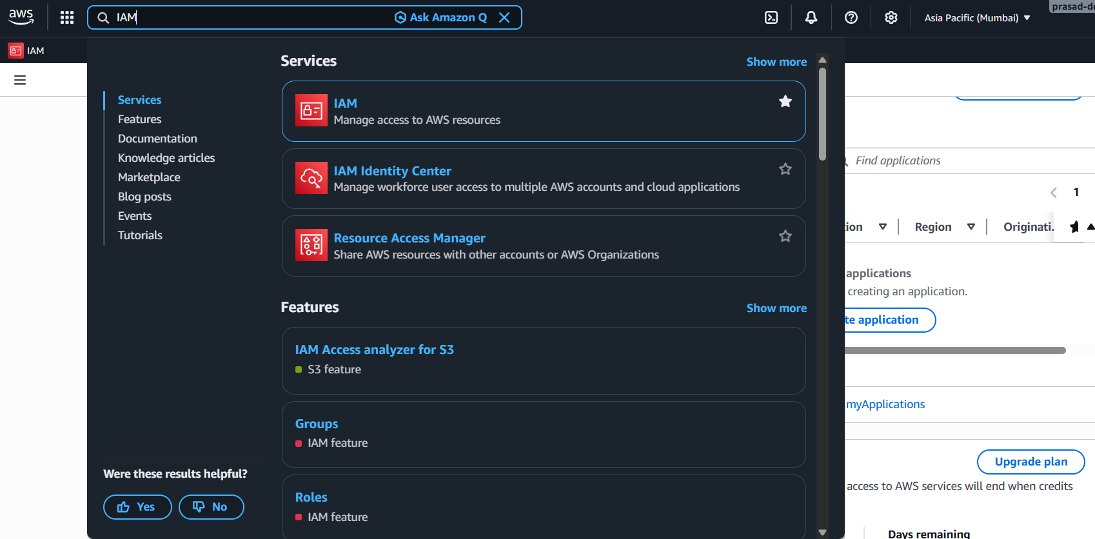

Step-2
IAM Dashboard will open and inside it clear User option in the left hand side user Access Management open that user section.
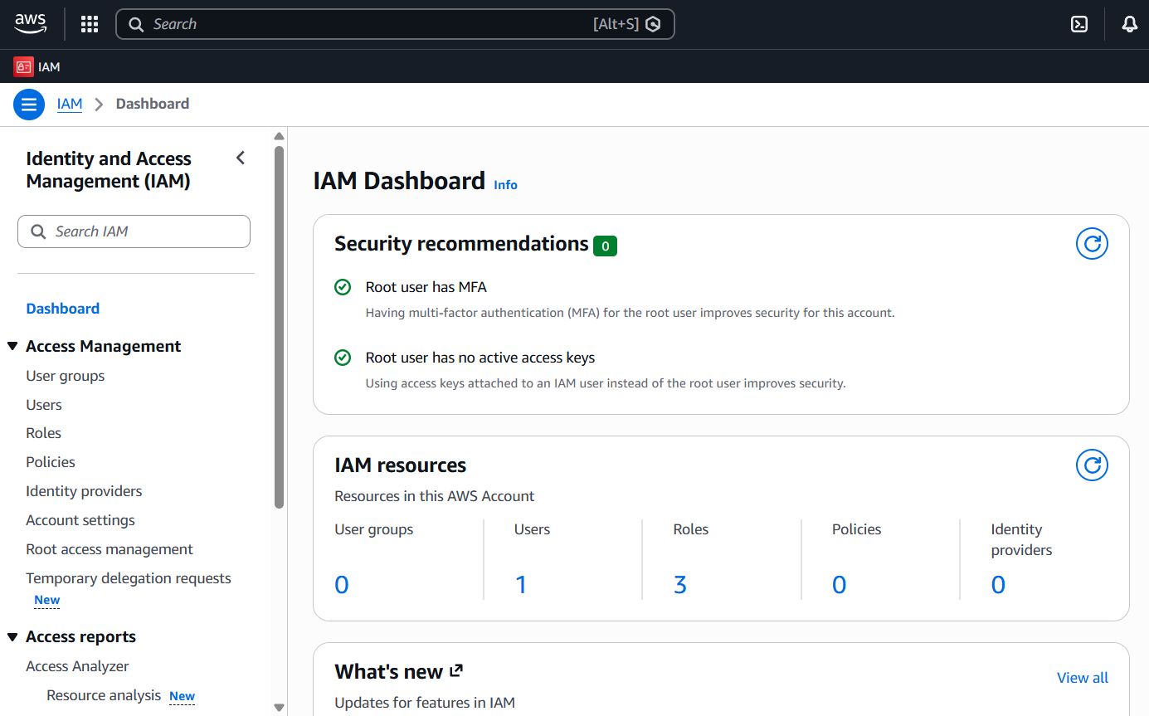
b. Click Create User button
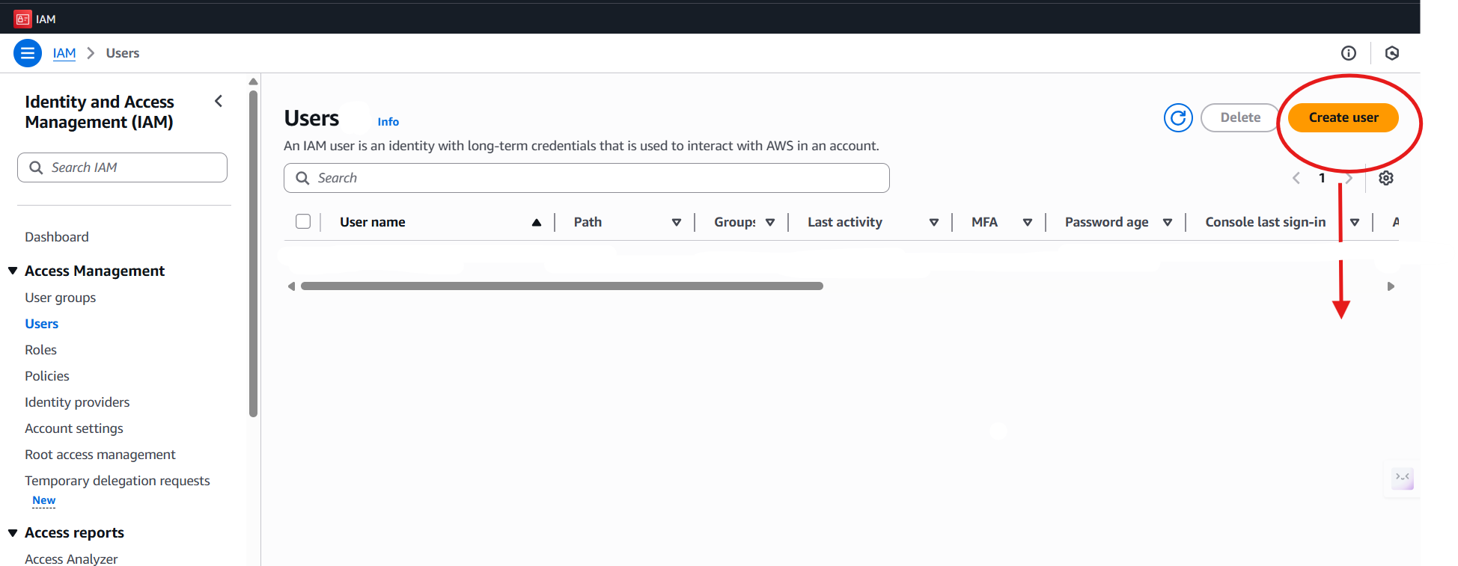

c. Give user name which should be Unique.
d. You can use auto generate password or can go with customized password.
e. Click next.
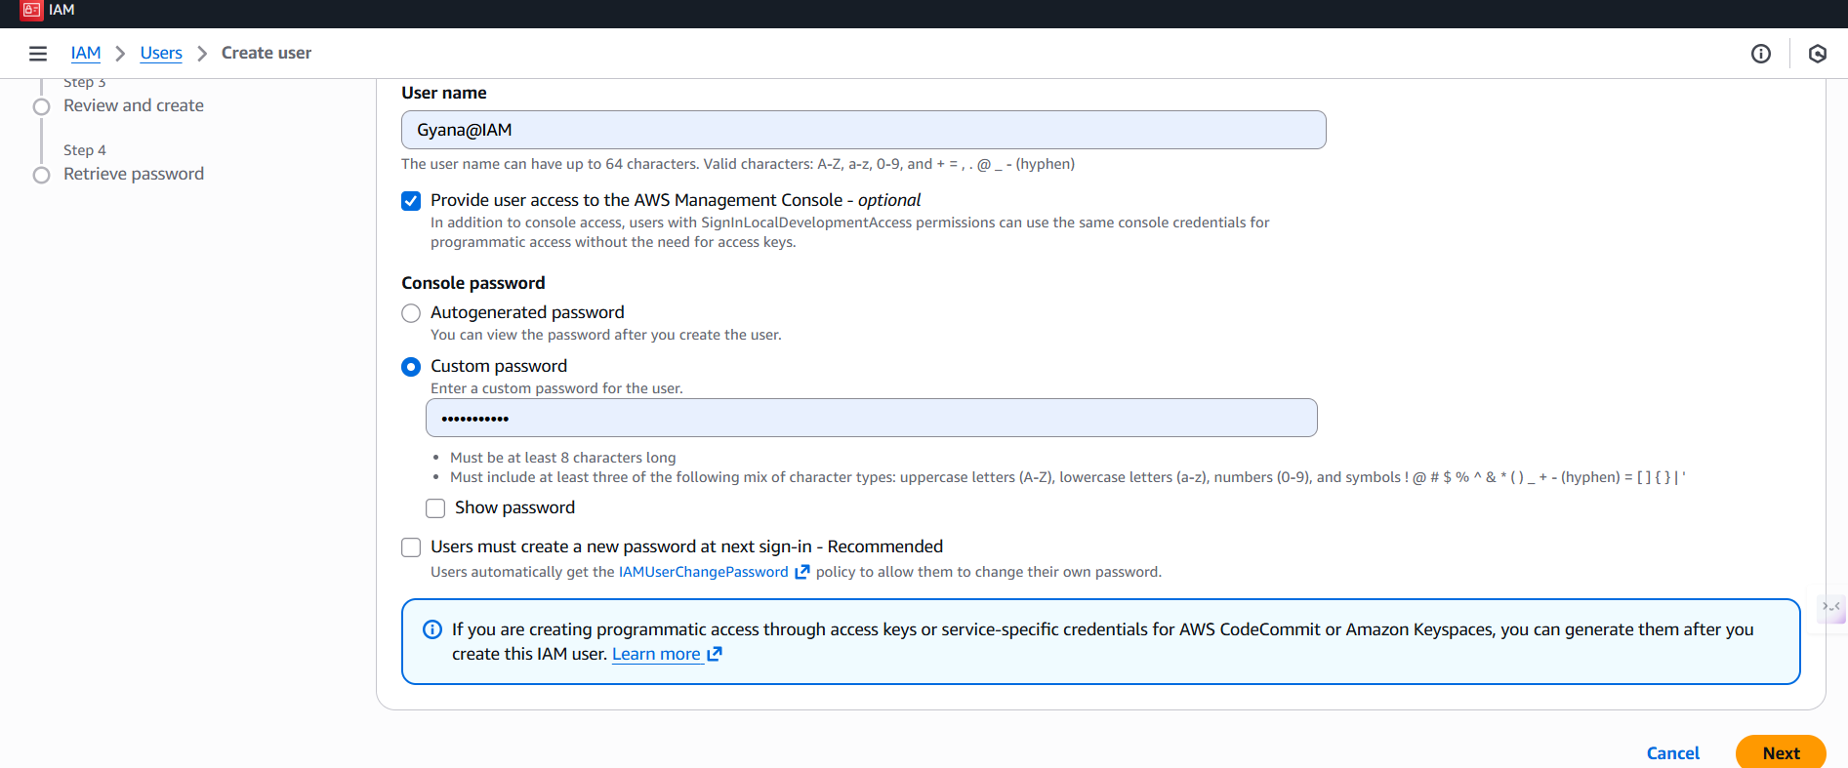

f. In this section we can give permissions or can remove permissions.
g. We can create our own permissions or customize our permissions in the create policy section which is nothing but the Inline Permission.
h. Click Next
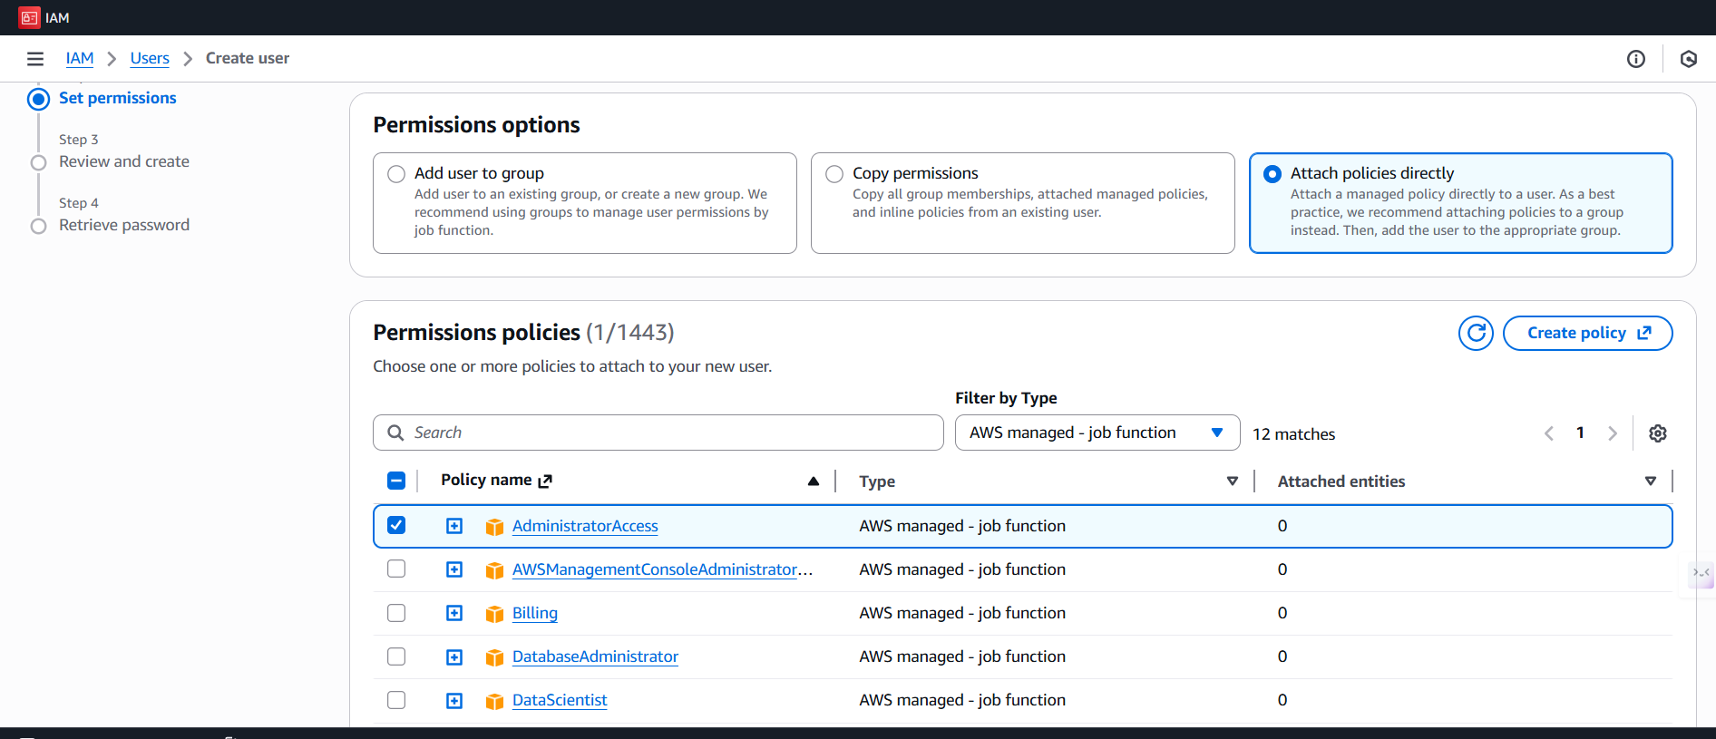

i.Review the user and now create.
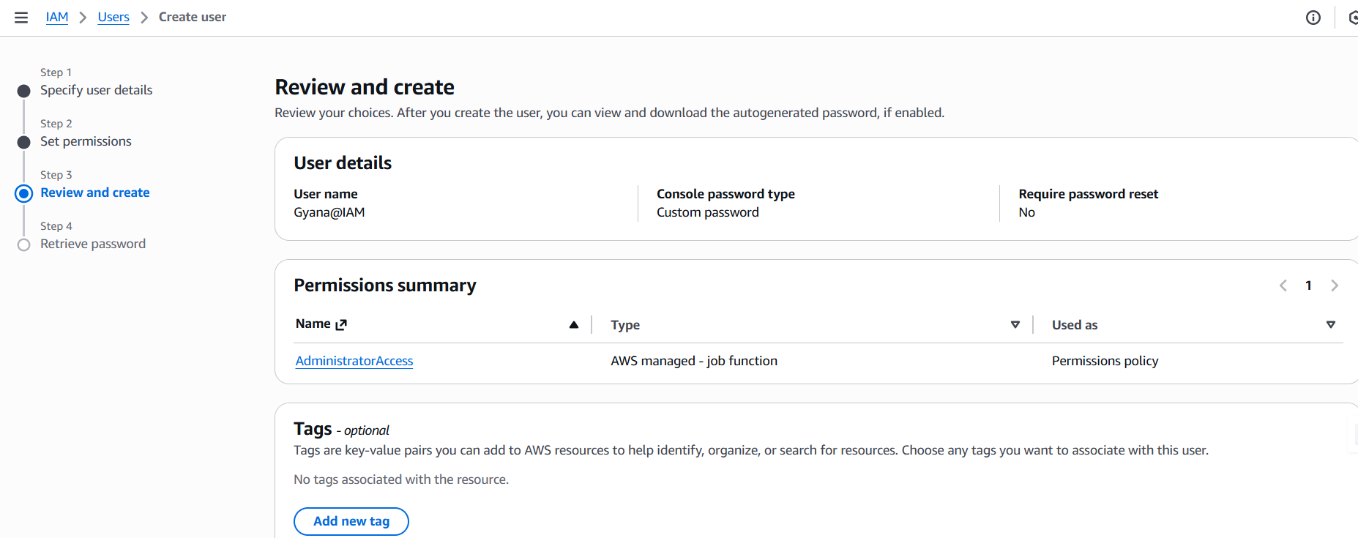
j. IAM user created successfully
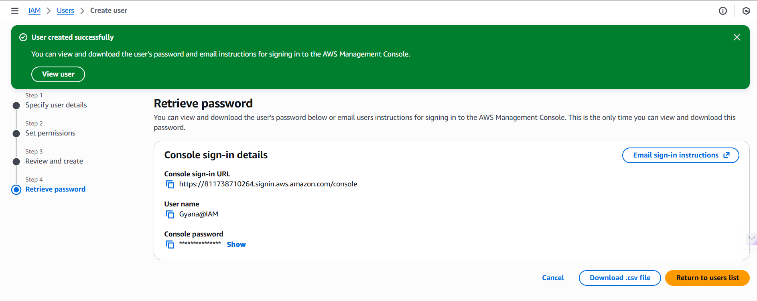
Here in this above image we can see a Download.csv file this file contails IAM user’s login details which can be shared to the preferred user by using those details he/she can join to this account.
-Here I have created an IAM User giving Administrative policy through I can use the services for my requiremetns.
- We can give any policies to the IAM user further also can remove and attached it.
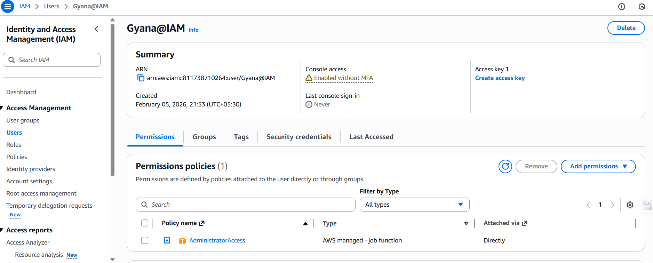
- Above image we can see we can create access key also add permissions and can remove and delete the IAM user.

Loing to the IAM USER
Sign out from the Root user and then Sign In again.
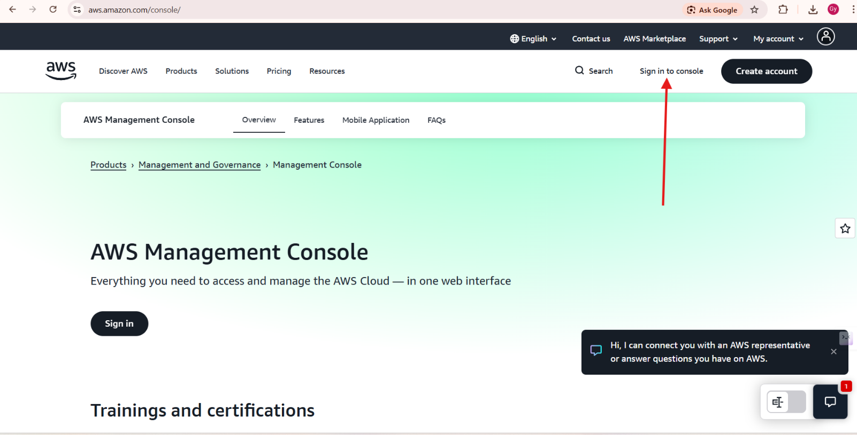

- We can Sign-in to the IAM user by using Username and password with giving alias name.
- The alias name will be created in the root user under the IAM service using create alias name.
- Without alias name we can’t login to the IAM user account.
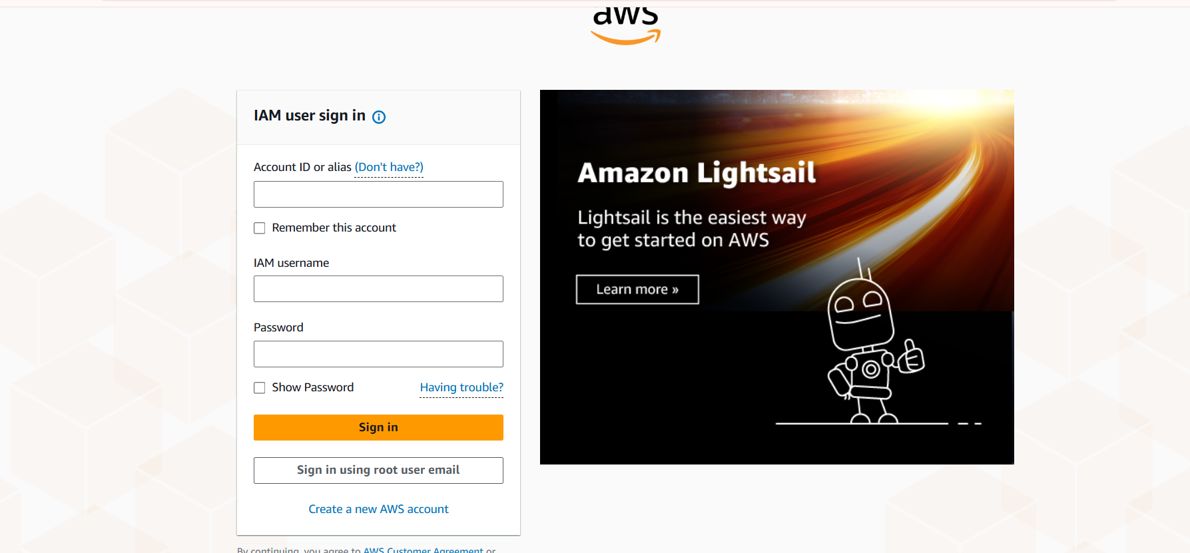
- Loged in to the IAM account.
